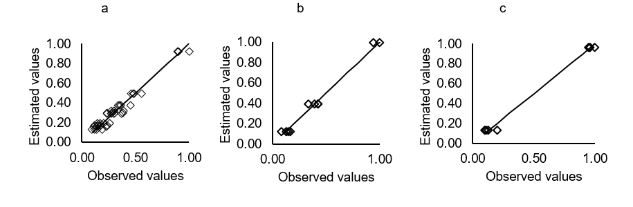
Figure 1. Residues estimated by the Modified Henderson and Pabis model for boldo leaves at the drying air temperatures of 20 (a), 40 (b), 60 (c).
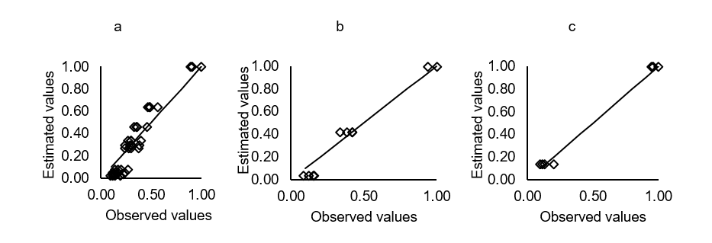
Figure 2. Residues estimated by the Newton model for the boldo leaves at the drying air temperatures of 20 (a), 40 (b), 60 (c).

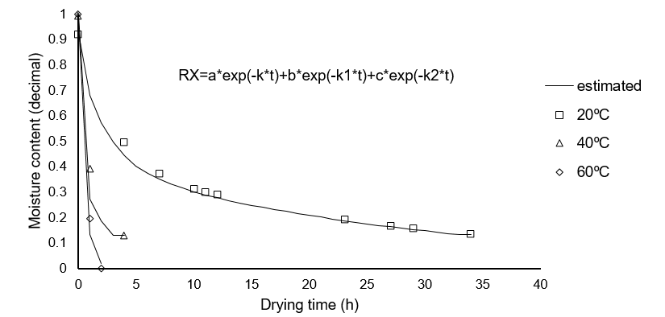
Figure 3. Drying curve of boldo leaves adjusted to the Modified Henderson and Pabis as function of temperatures.

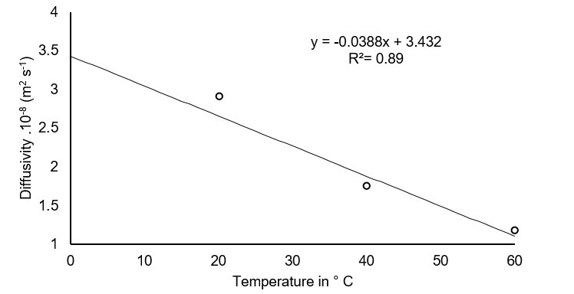
Figure 4. Average values of effective diffusion coefficient (m² s⁻¹) obtained for the drying of boldo leaves at three temperatures (20, 40 and 60°C).

