Scientific Article

Drying kinetics of passion fruit seeds

Cinética de secagem das sementes de maracujá

Abstract - After the extraction, passion fruit seeds present moisture content around 30% w.b., making their storage unviable. Thus, drying becomes an important tool for the safe storage of these seeds. Based on the study of the drying process, it is possible to obtain information regarding the phenomenon of heat and mass transfer between the product and the drying element, atmospheric air, heated or not. The objective of this work was to evaluate the drying kinetics of passion fruit seeds exposed to three drying conditions: full sun, half shade and shade (laboratory), as well as to determine their thermodynamic properties. The temperature was measured by means of a chemical thermometer (wet and dry bulb). For the validation of the drying equations, analysis of nonlinear regression of the mathematical models of drying to the experimental data was performed, the parameters of the models being related to the drying air temperature. The values ​​of the coefficient of determination (R²), mean relative error (P), estimated mean error (SE), and chi-square (X²) were used as criteria to verify the fitting degree of the mathematical models studied. The Wang and Singh model was the model that best fit the experimental data, with R² values ​​closer to the magnitude, X² and SE closer to 0 and smaller P. The sun drying condition obtained a greater efficiency in the water removal of passion fruit seeds.

Keywords: mathematical modeling; Passiflora edulis; moisture content.

Resumo - Após a extração, as sementes de maracujá apresentam teor de água em torno de 30% b.u., tornando inviável o seu armazenamento. A secagem entra como ferramenta importante para o armazenamento seguro dessas sementes. Com base no estudo do processo de secagem, é possível obter informações referentes ao fenômeno de transferência de calor e massa entre o produto e o elemento de secagem, ar atmosférico, aquecido ou não. Neste trabalho objetivou-se avaliar a cinética de secagem das sementes de maracujá expostos a três condições de secagem: sol pleno, meia sombra e sombra (laboratório), bem como determinar suas propriedades termodinâmicas. A temperatura foi medida por meio de termômetro químico, sendo em bulbo seco e bulbo úmido. Para a validação das equações de secagem, realizou-se a análise de regressão não linear dos modelos matemáticos de secagem aos dados experimentais, já os parâmetros dos modelos relacionam-se à temperatura do ar de secagem. Para verificação do grau de ajuste dos modelos matemáticos trabalhados, adotou-se como critério os valores do coeficiente de determinação (R²), os valores do erro médio relativo (P), do erro médio estimado (SE) e Qui-quadrado (X²). O modelo de Wang e Sinhg foi o modelo que melhor se ajustou aos dados experimentais, com valores de R² mais próximos a magnitude, X² e SE mais próximos de 0 e P menores. A condição de secagem ao sol obteve maior eficiência na remoção de água das sementes de maracujá.

Palavras-chave: modelagem matemática; Passiflora edulis; teor de água.

Introduction
Passion fruit belongs to the family Passifloraceae, originating in tropical America, with more than 150 species used for diverse purposes, from alimentary, medicinal, to ornamental (Pires et al., 2011). In Brazil, the most cultivated species are the yellow passion fruit (Passiflora edulis f. flavicarpa), purple passion fruit (Passiflora edulis Sims) and sweet passion fruit (Passiflora alata) (Coelho et al., 2016).
The success of the crop is directly related to seed production. Seeds need to be vigorous, productive, early matured, resistant to diseases and pests and originating from fruits with good quality (Lima, 2006).
Passion fruit seeds, after being extracted and washed, usually have a moisture content of around 30% w.b. (wet basis). It is practically unfeasible to store seeds for prolonged periods with high moisture contents, since, under these conditions, the seed metabolism is still intense (Carlesso et al., 2008). The viability of the seeds and, consequently, their greater or lesser longevity depends on the interaction between several factors, among them the moisture content, which occupies a prominent place (Peske et al., 2003). Fonseca (2004) reports that for storage, the combination of 7% moisture content with a temperature of 10 °C favors the maintenance of the physiological potential of the seeds of Passiflora edulis Sims f. flavicarpa Deg.
Drying consists of a complex process involving heat and mass transfer between the drying air and the product to be dried, where the increase in temperature increases the partial pressure of steam in the product, causing a reduction in the moisture content (Goneli et al., 2014).
According to Santos et al. (2012), drying occurs in the period of decreasing rate, showing that diffusion is probably the physical mechanism that governs the movement of moisture through the sample structure, that is, the drying rate is controlled by the rate of diffusion of the liquid by means of the solid, not having a defined constant rate period.
The simulation of the drying process makes it possible to obtain information about the behavior of the phenomenon of heat and mass transfer between the biological material and the drying element, usually atmospheric air, heated or not. Thus, this information is fundamental for the design, operation and simulation of drying systems and dryers (Corrêa et al., 2003).
As for seed drying procedures, Andrade et al. (2013) report better germination results of Passiflora nitida (sweet passion fruit) seeds subjected to sun drying (44% emergence), followed by seeds dried in a greenhouse (33% emergence) and under shade (18% emergence). Fresh seeds, which were not subjected to any drying process, presented the worst performance, with around 8% emergence.
The study of drying systems, considering the sizing, optimization and determination of the feasibility of their commercial application can be done by mathematical simulation, whose principle is based on the drying of successive thin layers of the product. This mathematical model satisfactorily represents the moisture loss of the product during the drying period (Afonso Júnior and Corrêa, 1999).
In view of the above, the objective was to fit and compare mathematical models that explain the drying process of the passion fruit seed in a natural environment.

Materials and Methods
The experiment was conducted at the Laboratory of Instrumental Chemistry of the IF Goiano - Ceres Campus, in the State of Goiás, on August 18, 2016.
The fruits of passion fruit BRS Gigante Amarelo were purchased in Ceres and presented exocarp of yellowish green color, or with around 55% of yellow color in the bark, optimal harvest point according to Santos et al. (2013). One day before drying, the fruits were depulped and the seeds removed. For the removal of aryl, a blender was used in the pulse mode, then the seeds were washed in running tap water to separate broken seeds and mucilage, being subsequently dried under shade on newspaper, to lose surface moisture (Osipi et al., 2011).
In the laboratory, the seeds were placed in Petri dishes, where they were prepared in triplicates for each evaluation environment. A wet and dry bulb thermometer was used on the bench of the Laboratory of Instrumental Chemistry. Samples were weighed in an analytical balance with precision to three decimal places. Each Petri dish was identified and received, on average, 10 grams of seeds, in thin layer, being weighed and taken to the drying place. The first triplicate was exposed directly to the sun and placed in trays on a chair, under an average temperature of 25.8 °C and 32% RH. The second triplicate was placed in half shade, with the Petri dishes being arranged inside a polystyrene box under the sun, so that there was no direct incidence of solar rays on the sample, with an average temperature of 25.8 °C and 32% RH. The third triplicate was placed on the laboratory bench, under an average temperature of 25 °C and 68% RH.
To obtain the initial moisture content, a triplicate similar to the other samples was prepared and taken to a forced-ventilation oven at 105 °C for 24 hours (BRASIL, 2009).
In order to determine the moisture content ratios (RX) of the sample in the different drying situations, Equation 1 was used:
RX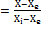 (1)
In which: RX = moisture content ratio, dimensionless; X = moisture content of the product at time t, dry basis decimal; Xe = equilibrium moisture content of the product, dry basis decimal; and Xi = initial moisture content of the product, dry basis decimal.
Mathematical models used in different works were fitted to the experimental data of passion fruit seed drying, for example, drying of chilli pepper seeds (Santos et al., 2012), cowpea seeds (Camicia et al., 2015), lemongrass leaves (Martinazzo et al., 2007), and goat pepper grains (Rodovalho et al., 2015), as described (Table 1).

Table 1 - Mathematical models used to predict the drying of agricultural products in thin layers.
Model | Name of the model
RX=a.exp(-k.t)+(1-a).exp(-k.b.t) | Diffusion Approximation | (2)
RX=a.exp(-k.t)+b.exp(-k1.t) | Two Terms | (3)
RX=a.exp(-k.t)+(1-a).exp(-k.a.t) | Two Terms Exponential | (4)
RX=a.exp(-k.t) | Henderson and Pabis | (5)
RX=a.exp(-k.t)+b | Logarithmic | (6)
RX=exp(-k.t^{n})+a.t | Modified Midilli | (7)
RX=exp(-k.t) | Newton | (8)
RX = exp (-k. t^{n}) | Page | (9)
RX = exp[-(k. t)^{n}] | Modified Page | (10)
RX=exp [-a-(a²+4.b.t)^{0,5}/(2.b)] | Thompson | (11)
RX=a.exp(-k.t)+(1-a).exp(-b.t) | Verma | (12)
RX=1+(a.t)+(b.t²) | Wang and Singh | (13)
In which: RX – moisture content ratio of the grain, dimensionless; t - drying time, hours; k - coefficient of drying; “a”, “b”, “c”, “d” and “m” - constants of the models.

For fitting the mathematical models of drying to the experimental data, nonlinear regression analysis was performed at 5% probability by a t-test of the parameters using the STATISTICA 7.0® software.
Aiming to select the best models that represent the drying kinetics of passion fruit seeds, we considered the magnitude of the coefficient of determination fitted by the model (R²); the mean relative error (P) represented by Equation 14; the estimated mean error (SE), by Equation 15; the chi-square test, by Equation 16; and the residue distribution behavior.

(14)
(15)
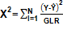 (16)
In which: P - mean relative error (%), SE - estimated mean error, n - number of cases, Y - experimental value, Ŷ - estimated value, GLR - degree of freedom of the model (number of experimental observations minus the number of model coefficients), X² - chi-square.
With the use of an analog caliper, the orthogonal axes of 50 seeds were measured in order to calculate their effective diffusivity.
The thermodynamic properties specific enthalpy (Δh), specific entropy (Δs) and Gibbs free energy (ΔG) related to the drying process of passion fruit seeds were obtained by equations 16, 17 and 18, with the values of the estimated diffusivity.

(16)
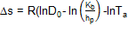 (17)
(18)
In which: ∆h – specific enthalpy (J mol⁻¹), ∆s – specific entropy (J mol K⁻¹), ∆G – Gibbs free energy (J mol⁻¹), Kb – Boltzmann’s constant (1.38 x 10⁻²³ JK⁻¹), Hp – Planck’s constant (6.626 x 10⁻³⁴ J⁻¹).

Results and Discussion
The initial moisture content of the seeds was 0.7 (d.b.), reaching up to 0.4 (d.b.) at the end of drying. The drying period was 7h for the three situations studied (Figure 1). As expected, the drying time decreased with increasing drying air temperature (Figure 1), a situation also observed by Andrade et al. (2013) in the drying of bush passion fruit seeds at temperatures of 50, 60, and 70 °C in a fixed-bed dryer. Carlesso et al. (2005) also observed this behavior in the drying of yellow passion fruit seeds with temperatures of 30, 37 and 40 °C in a fixed-bed drier. As the temperature rises, the kinetic energy of the system increases, which causes a decrease in the attraction forces between the water molecules and the other constituents that make up the material, leading to a decrease in humidity (Castiglioni et al., 2013).
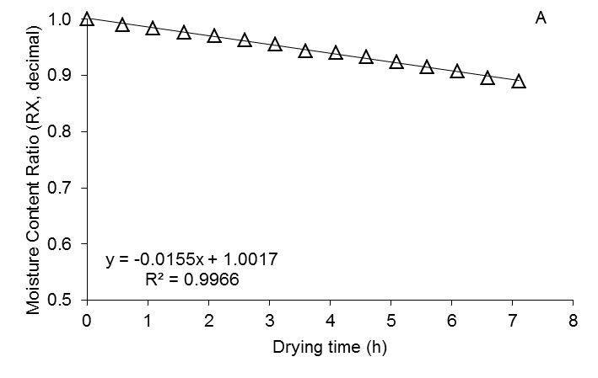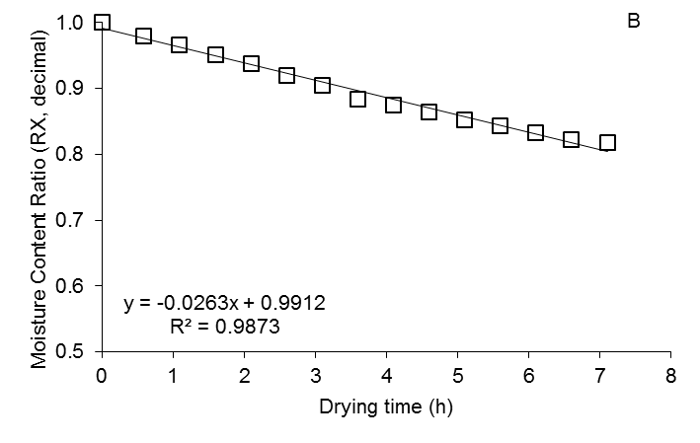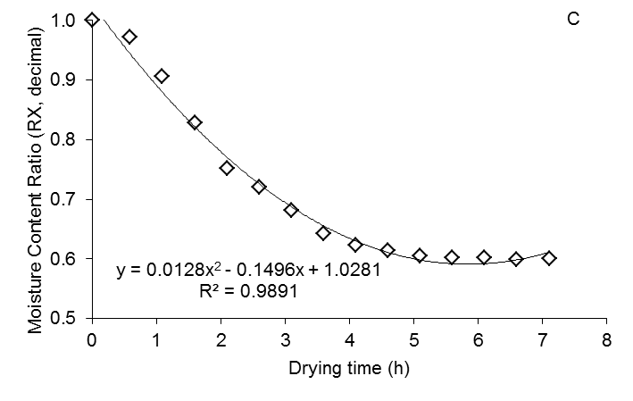
Figure 1. Experimental data of drying in three situations: laboratory bench (A), shade (B) and sun (C) of passion fruit seeds subjected to kinetics.

According to Mahapatra & Rao (2005), the use of the coefficient of determination (R²) as the sole evaluation criterion for the selection of drying models is not a good parameter, being necessary to jointly analyze other statistical parameters. Table 2 shows the values ​​of the various parameters of the mathematical models used, fitted to the experimental data of the drying kinetics with the respective values of the coefficients of determination (R²), chi-square (X²), estimated mean error (SE) and mean relative error (P).
The mathematical models Wang and Singh, Diffusion Approximation and modified Midili presented satisfactory fittings to the experimental data, expressing R² above 98% for all situations studied. These results agree with those found by Costa et al. (2015), in which the Diffusion Approximation model presented R² above 99% for the drying of crambe fruits in thin layer. Meneghetti et al. (2012) report the Wang and Singh model with R² above 99% for rice drying.
For X², SE and P, the mathematical model Wang and Singh presents the best values ​​for the three situations studied: estimated mean error (SE) below 0.01; X² below 0.0003 and P below 1% (Table 2). According to Mohapatra & Rao (2005), lower values of estimated mean error (SE) and magnitudes of mean relative error (P) below 10% indicate that the model used is adequate to describe a drying process. Helmich et al. (2014) observed adequacy of the Wang and Singh model to the experimental data of sunflower seeds with drying temperatures of 45 to 75 °C.

Table 2. Values of the parameters of the mathematical models adjusted to the experimental data of the drying kinetics with the respective coefficients of determination (R²), Chi-square (X²) estimated mean error (SE) and relative mean error (P).
Models | R² |  |  | X²
Models | Sun | Shade | Laboratory bench | Sun | Shade | Laboratory bench
Diffusion Aproximation | 98.31 | 99.85 | 99.79 | 0.0003229 | 0.0000048 | 0.0000022
Two Terms | 98.81 | 0 | 0 | 0.0002274 | 0.5686465 | 0.6449705
Two Terms Exponential | 92.77 | 99.66 | 99.35 | 0.0013827 | 0.0000110 | 0.0000073
Henderson and Pabis | 88.89 | 99.23 | 99.5 | 0.0021235 | 0.0000255 | 0.0000056
Logarithmic | 97.61 | 99.73 | 99.81 | 0.0004565 | 0.0000087 | 0.0000020
Modified Midili | 99.46 | 99.85 | 99.75 | 0.0001017 | 0.0000049 | 0.0000028
Newton | 87.16 | 99.03 | 99.35 | 0.0024558 | 0.0000321 | 0.0000073
Page | 93.2 | 9952 | 93.20 | 0.0012989 | 0.0000157 | 0.0000029
Modified Page | 93.2 | 99.52 | 99.74 | 0.0012989 | 0.0000157 | 0.0000029
Thompson | 94.47 | 99.66 | 99.81 | 0.0010572 | 0.0000112 | 0.0000021
Verma | 86.71 | 0 | 0 | 0.0025415 | 0.0425037 | 0.0682449
Wang and Singh | 98.33 | 99.76 | 99.8 | 0.0003192 | 0.0000080 | 0.0000022
 | SE |  |  | P (%)
 | Sun | Shade | Laboratory bench | Sun | Shade | Laboratory bench
Diffusion Aproximation | 0.01797 | 0.00219 | 0.00152 | 1.10192 | 0.09660 | 0.06222
Two Terms | 0.01508 | 0.75409 | 0.80310 | 1.00112 | 38.74955 | 39.02051
Two Terms Exponential | 0.03718 | 0.00332 | 0.00270 | 2.28797 | 0.17530 | 0.09034
Henderson and Pabis | 0.04608 | 0.00505 | 0.00237 | 3.04211 | 0.29149 | 0.10165
Logarithmic | 0.02137 | 0.00295 | 0.00143 | 1.65742 | 0.16517 | 0.05722
Modified Midili | 0.01009 | 0.00222 | 0.00167 | 0.46870 | 0.10456 | 0.07516
Newton | 0.04956 | 0.00566 | 0.00270 | 2.72879 | 0.28983 | 0.09034
Page | 0.03604 | 0.00396 | 0.00171 | 2.52590 | 0.22107 | 0.07999
Modified Page | 0.03604 | 0.00396 | 0.00171 | 2.52590 | 0.22107 | 0.07999
Thompson | 0.03251 | 0.00335 | 0.00144 | 2.28952 | 0.17667 | 0.05875
Verma | 0.05041 | 0.20616 | 0.26124 | 2.66729 | 7.08107 | 8.43589
Wang and Singh | 0.01787 | 0.00282 | 0.00148 | 1.08470 | 0.14105 | 0.05914

The results obtained for the parameters of the analyzed equations, fitted to the experimental data of the drying of passion fruit seeds in thin layer, in which the parameters of the analyzed models can be observed, were not all significant, with Wang and Singh being significant in all three situations (Table 3).
aC
The drying constant (k) can be used as an approach to characterize the effect of temperature. It is related to the effective diffusivity of the drying process in the decreasing period and to the liquid diffusion that controls the process (Babalis & Belessiotis, 2004, apud Araújo et al., 2017). The following models: Logarithmic, Two Terms, Newton, and Page present an increase of coefficient "k" with increased temperature (Table 3), a fact observed by Rodovalho et al. (2015) in the drying of goat pepper grains, indicating that the effective diffusivity controls the entire drying process in the decreasing period. This behavior, according to Santos et al. (2012), shows that diffusion is probably the physical mechanism that governs the movement of moisture through the sample structure, that is, the drying rate is controlled by the rate of diffusion of the liquid through the solid, not presenting a defined constant rate period.
The coefficients "a”, “b” and “n" of the models fitted to the experimental data obtained from the passion fruit seeds did not present a clear trend of behavior with the rise of temperature, in this case, they can be treated as empirical variables (Table 3).
Table 3. Data of the parameters of the equations for the drying kinetics of the seeds.
Models | Parameters | Drying Environments
Models | Parameters | Sun | Shade | Laboratory bench
Diffusion Aproximation | A | 0.98163* | 0.99967* | -4.40758 ^{ns}
Diffusion Aproximation | K | 0.14080* | 0.03322* | 0.04784 ^{ns}
Diffusion Aproximation | B | -2.61418 ^{ns} | -18.9597 ^{ns} | 0.86705 ^{ns}
Two Terms | A | 0.97637* | 0.1* | 0.1*
Two Terms | K | 0.17345* | 0.1* | 0.1*
Two Terms | B | 0.05346^{ns} | 0.1* | 0.1*
Two Terms | k1 | -0.254520 ^{ns} | 0.1* | 0.1*
Two Terms Exponential | A | 0.126240 ^{ns} | 0.10265* | 0.993480 ^{ns}
Two Terms Exponential | K | 0.563000 ^{ns} | 0.18451* | 0.015790 ^{ns}
Henderson and Pabis | A | 0.95894* | 0.99479* | 1.00255*
Henderson and Pabis | K | 0.08632* | 0.02951* | 0.01632*
Logarithmic | A | 0.49219* | 0.36859* | -0.32074*
Logarithmic | K | 0.39488* | 0.10111* | -0.04149*
Logarithmic | B | 0.54796* | 0.63399* | 1.31986*
Modified Midilli | K | 0.18384* | 0.06692* | -0.008350 ^{ns}
Modified Midilli | N | 1.27033* | 1.08348* | 0.851950 ^{ns}
Modified Midilli | A | 0.07118* | 0.03451* | -0.021790 ^{ns}
Newton | K | 0.09624* | 0.03062* | 0.01579*
Page | K | 0.15083* | 0.03604* | 0.01327*
Page | N | 0.70759* | 0.89978* | 1.10525*
Modified Page | K | 0.15083* | 0.03604* | 0.01327*
Modified Page | N | 0.70759* | 0.89978* | 1.10525*
Thompson | A | -5.43059* | -27.58831)* | -71.78980*
Thompson | B | 10.77263* | 31.38000* | -96.54544*
Verma | A | 0.1* | 0.100000 ^{ns} | 0.100000 ^{ns}
Verma | K | 0.1* | 0.100000 ^{ns} | 0.100000 ^{ns}
Verma | k1 | 0.1* | 0.100000 ^{ns} | 0.100000 ^{ns}
Wang and Singh | A | -0.13445* | -0.03500* | -0.01369*
Wang and Singh | B | 0.01109* | 0.00124* | -0.00026*
* Significant at 5% probability by the t test; ns Not significant at 5% probability by t test.

It is possible to observe values ​​of sphericity, circularity and geometric diameter of the passion fruit seeds in order to calculate the seed volume (SV), since in the case of these seeds, for the calculation of diffusivity, they cannot be considered as spherical (Table 4).

Table 4. Orthogonal axes (a, b and c), volume (V), sphericity (S), circularity (C), geometric diameter (GD) and surface area (A) of passion fruit seeds.
A (m) | B (m) | C (m) | V (m³) | S (%) | C (%) | GD (m) | A (m²)
6.574 | 4.425 | 1.760 | 2.681 10⁻⁸ | 56.484 | 148.565 | 3.730 10⁻³ | 1.167 10⁻⁵

The diffusion coefficient showed an increasing trend with the rise of temperature, which was expected, since, according to Corrêa et al. (2010), once the temperature is raised, the water viscosity decreases. This property directly influences the resistance of the fluid to the flow; therefore, its reduction eases the diffusion of the water molecules in the seed capillaries (Figure 2).
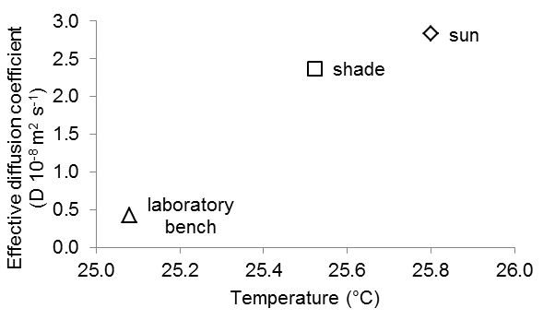
Figure 2. Effective diffusion coefficient (D) values (m² s⁻¹) obtained for drying the passion fruit seeds submitted to direct drying in the sun, shade and laboratory bench.

Table 5 shows that the enthalpy (ΔH) value decreased from 2.728 to 2.722 kJ mol⁻¹ with increasing temperature. According to Rodovalho et al. (1995), this indicates the need for less energy to remove the water bound to the grain during drying, i.e., at higher temperatures, less energy is required for drying to occur (Corrêa et al., 2010).

Table 5. Thermodynamic properties, enthalpy (δH), entropy (δS) and gibbs free energy (δG) obtained by drying the passion fruit seeds directly in the sun, in the shade and in laboratory benches.
Drying | t (°C) | ∆H | ∆S | ∆G
Sun | 25.8±3.87 | 2.728 | -1.202 | 3.622
Shade | 25.52±3.1.3 | 2.725 | -1.202 | 3.618
Laboratory bench | 25.08±3.87 | 2.722 | -1.202 | 3.613

The obtained value of entropy (ΔS) was -1.202 kJ mol⁻¹, remaining constant for all temperatures: 25; 25.5 and 25.8 °C. Negative entropy values ​​can be attributed to the existence of chemical alterations or changes in the grain structure during the drying process (Corrêa et al., 2010).
The values of Gibbs free energy ​​(ΔG) increased with increasing temperature, as shown in Table 5. In this case, the drying process was not spontaneous, requiring the addition of an energy from the air, in which the seed was involved, for the moisture content reduction to occur.

Conclusions
The Wang and Singh model represented the best drying kinetics of passion fruit seeds, presenting the following values: R² (98.22%; 99.76%; 99.8%), X² (0.0003192; 0.000008; 0.0000022), SE (0.01787; 0.00282; 0.00148) and P (1.0847%; 0.14105%; 0.05914%), for the respective conditions of sun, shade and bench drying.
Direct sun drying made it possible to reduce water in less time than shade drying and laboratory bench drying.
The increase of the drying temperature allowed the increase of diffusivity, Gibbs free energy, and enthalpy, and maintained the entropy negative.

References

Andrade JKS, Silva GF, Barretto LCO, Santos JAB (2013) Estudo da cinética de secagem, extração, caracterização e estabilidade térmica do óleo das sementes de maracujá do mato (passiflora cincinnata MAST.). Revista Geintec 3(5): 283-291.

Afonso júnior PC, Corrêa PC (1999) Comparação de modelos matemáticos para descrição da cinética de secagem em camada fina de sementes de feijão. Revista Brasileira de Engenharia Agrícola e Ambiental 3(3): 349-353.

Barbalis SJ, Belessiotis VG (2004) Influence of the conditions on the drying constants and water diffusivity during the thin-layer drying of figs. IN: Araújo WD, Goneli ALD, Corrêa PC, Hartmann Filho CP, Martins EAS (2017) Modelagem matemática da secagem dos frutos de amendoim em camada delgada. Revista Ciência Agronômica 48(3): 448-457.

Brasil (2009) Regras para análise de sementes. Ministério da Agricultura e Reforma Agrária. 398p.

Carlesso VO, Berbert PA, Silva RF, Detmann E (2008) Secagem e armazenamento de sementes de maracujá amarelo (Passiflora edulis Sims f. flavicarpa Degener). Revista Brasileira de Sementes 30(2): 65-74.

Castiglioni GL, Silva FA, Caliari M, Soares Junior MS (2013) Modelagem matemática do processo de secagem da massa fibrosa de mandioca. Revista Brasileira de Engenharia Agrícola e Ambiental 17(9): 987–994.

Camicia RGM, Christ D, Coelho SRM, Camicia RFM (2015) Modelagem do processo de secagem de sementes de feijão-caupi. Revista Caatinga 28(3): 206-214.

Coelho EM, Azêvedo LC, Umsza-Guez MA (2016) Fruto do maracujá: importância econômica e industrial, produção, subprodutos e prospecção tecnológica. Caderno de Prospecção 9(3): 323-336.

Corrêa PC, Araújo EF, Afonso Júnior, PC (2003) Determinação dos parâmetros de secagem em camada delgada de sementes de milho doce (Zea mays L.). Revista Brasileira de Milho e Sorgo 2(2): 110-119.

Corrêa PC, Oliveira GHH, Botelho FM, Goneli ALD, Carvalho FM (2010) Modelagem matemática e determinação das propriedades termodinâmicas do café (Coffea arabica L.) durante o processo de secagem. Revista Ceres 57(5): 595-601.

Costa LM, Resende O, Gonçalves DN, Oliveira DEC (2015) Modelagem matemática da secagem de frutos de crambe em camada delgada. Bioscience Journal 31(2): 392-403.

Fonseca SCL (2004) Conservação de sementes de maracujá-amarelo (Passiflora edulis Sims f. flavicarpa Degener.) interferências do teor de água das sementes e da temperatura do ambiente. Esalq (Tese de doutorado em Fitotecnia).

Goneli ALD, Nasu AK, Gancedo R, Araújo WD, Sarath KLL (2014) Cinética de secagem de folhas de erva baleeira (Cordina verbenácea DC.). Revista Brasileira de Plantas Medicinais 16(2): 434-443.

Lima AA (2006) A cultura do maracujá. Embrapa Informação Tecnológica, 24p.

Mahapatra D, Rao OS (2005) A thin layer drying model of parboiled wheat. Journal of Food Engineering 66(4): 513-518.

Martinazzo AP, Corrêa PC, Resende O, Melo EC (2007) Análise e descrição matemática da cinética de secagem de folhas de capim-limão. Revista Brasileira de Engenharia Agrícola e Ambiental 11(3): 301-306.

Meneghetti VL, Aosani E, Rocha JC, Oliveira M, Elias MC, Pohndorf RS (2012) Modelos matemáticos para a secagem intermitente de arroz em casca. Revista Brasileira de Engenharia Agrícola e Ambiental 16(10): 1115-1120.

Oba GC (2016) Caracterização física de sementes de feijão-caupi durante o processo de secagem. UFGD (Dissertação de mestrado em Agronomia).

Osipi EA, Lima FCB, Cossa CA (2011) Influência de métodos de remoção do arilo na qualidade fisiológica de sementes de Passiflora alata Curtis. Revista Brasileira de Fruticultura (volume especial): 680-685.

Peske ST, Rosenthal MD, Rota GRM (2012) Sementes Fundamentos científicos e tecnológicos. Editora Becker & Peske Ltda. 573p.

Pires MM, são josé AR, Conceição AO (2011) Maracujá: avanços tecnológicos e sustentabilidade. Editus. 237p.

Rodovalho RS, Silva HW, Silva IL, Rosseto CAV (2015) Cinética de secagem dos grãos de pimenta bode. Global Science and Technology 8(2): 128-142.

Santos JLV, Resende ED, Martins DR, Gravina GA, Cenci AS, Maldonado JFM (2013) Determinação do ponto de colheita de diferentes cultivares de maracujá. Revista Brasileira de Engenharia Agrícola e Ambiental 17(7): 750–755.

Santos JAB, Silva GF, Pagani AAC (2012) Estudo da Cinética de Secagem de Sementes da Pimenta Malagueta (Capsicum spp.) Cultivada no Estado de Sergipe. Revista Geintec 2(5): 465-471.

